Modeling Chat Data using a Graph Data Model
Using a Graph Data Model to illustrate the chatting interaction among users with Chat Data. A user in a team can create a chat session and then create chat (i.e. chat item) in the chat session. Otherwise, a user could be mentioned by a chat item, and a chat item can response to another chat item, which represent the communication among the users in the same team. Moreover, a user can also join in an existed team chat session or leave it.

Creation of the Graph Database for Chats
CSV Files
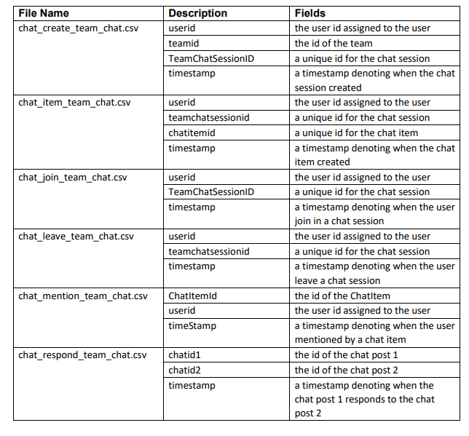
Loading Process

Using Cypher Query Language to load the CSV data into neo4j, each row of script is parsed for refine the nodes, the edges and its timestamp. Let’s consult the following script as an example:

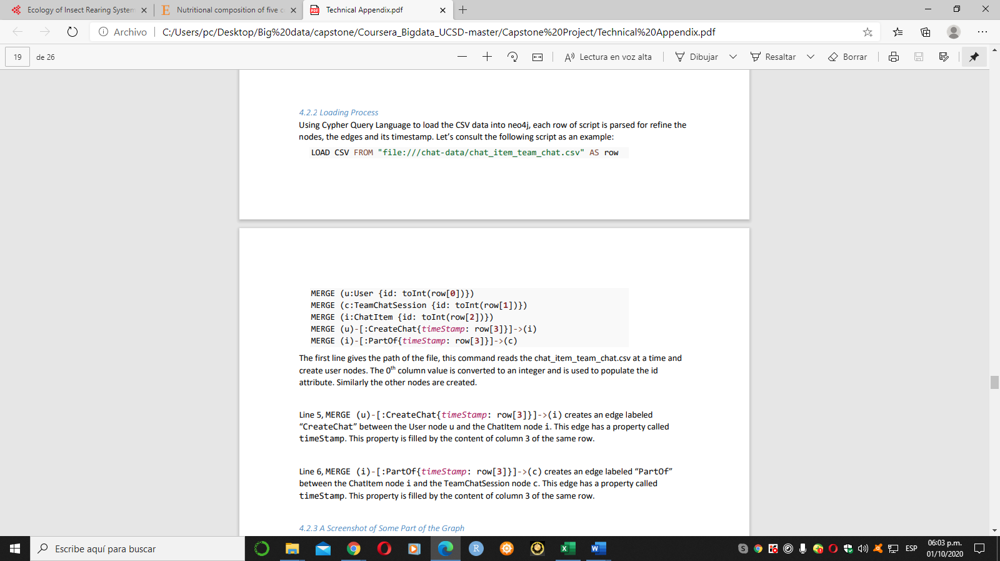
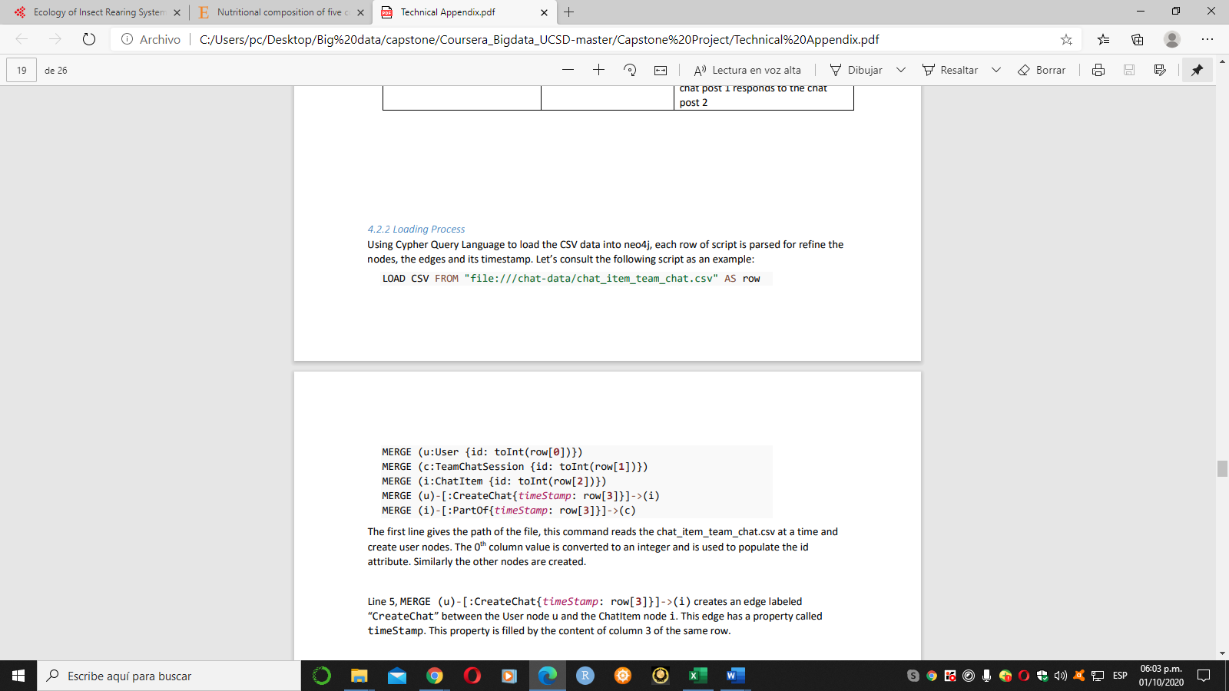

The first line gives the path of the file, this command reads the chat_item_team_chat.csv at a time and create user nodes. The 0th column value is converted to an integer and is used to populate the id attribute. Similarly the other nodes are created.

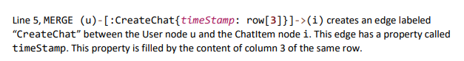

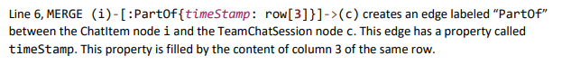

4.2.3 A Screenshot of Some Part of the Graph
The graphs must include clearly visible examples of most node and edge types. Below are two acceptable examples. The first example is a rendered in the default Neo4j distribution, the second has had some nodes moved to expose the edges more clearly. Both include examples of most node and edge types.
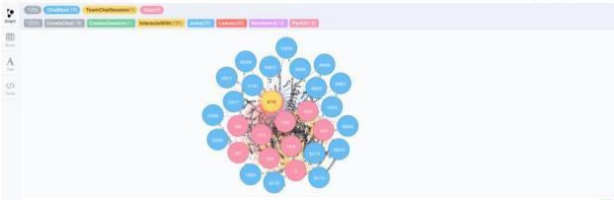
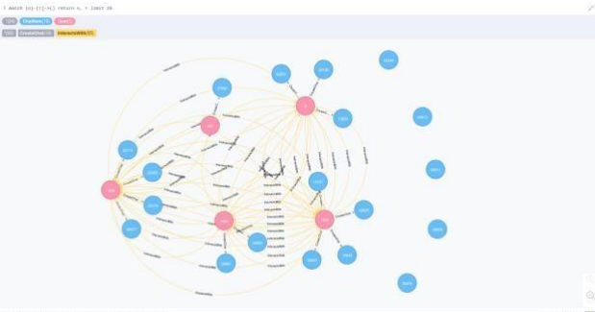

The longest conversation chain and its participants
• finding the longest conversation chain
The longest conversation chain is traced via ChatItem nodes which are connected by ResponseTo edges, order the length and find the longest one. Running the following query, we get the longest conversation chain has path length of 9, i.e. the longest conversation has 10 chats.
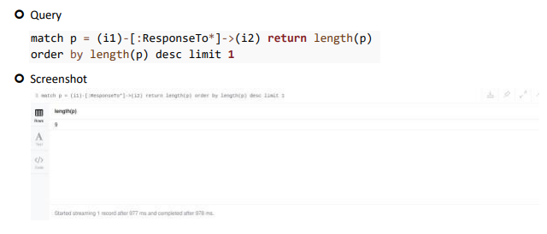

• how many unique users were part of this chain? Since we’ve already known the longest conversation chain has path length of 9, next we will find all the distinct users which are part of this path. After running the following query, 5 unique users are extracted.

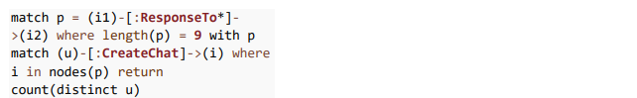
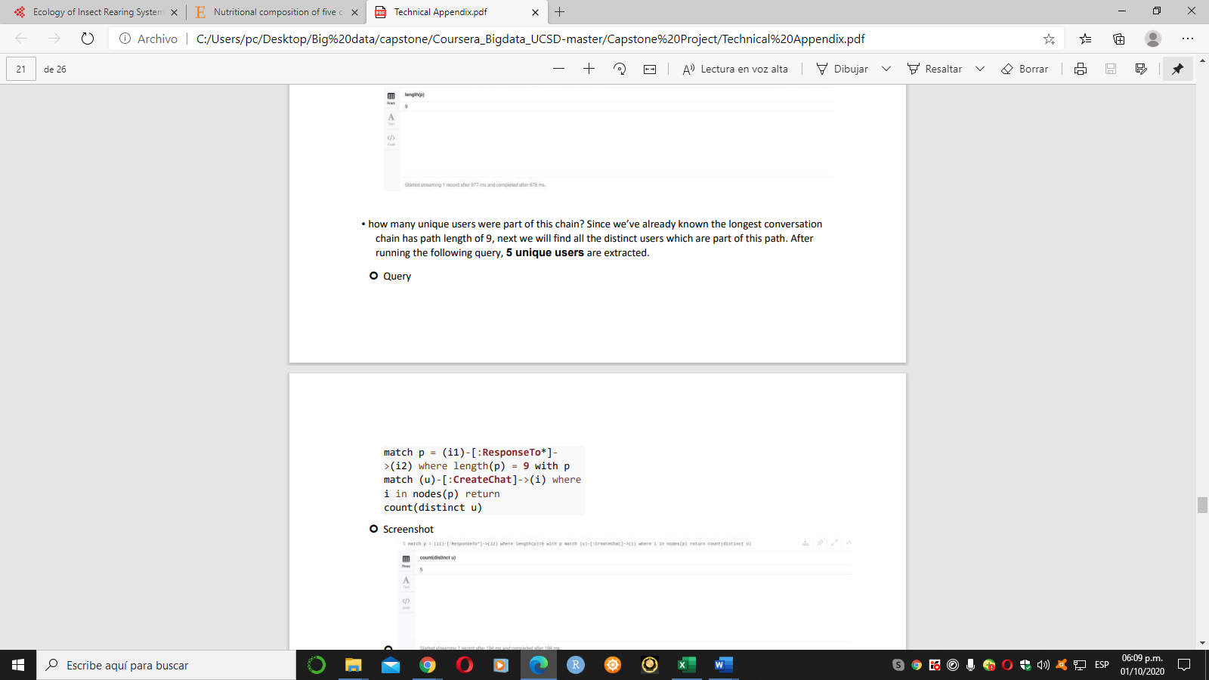

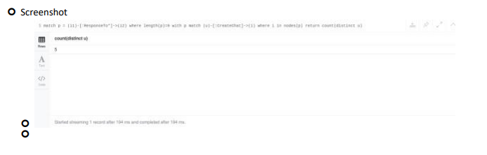

The relationship between top 10 chattiest users and top 10 chattiest teams
Describe your steps from Question 2. In the process, create the following two tables. You only need to include the top 3 for each table. Identify and report whether any of the chattiest users were part of any of the chattiest teams.
Chattiest Users
We firstly match the CreateChat edge from User node to ChatItem node, then return the ChatItem amount per user, and order by the amount in descending order.

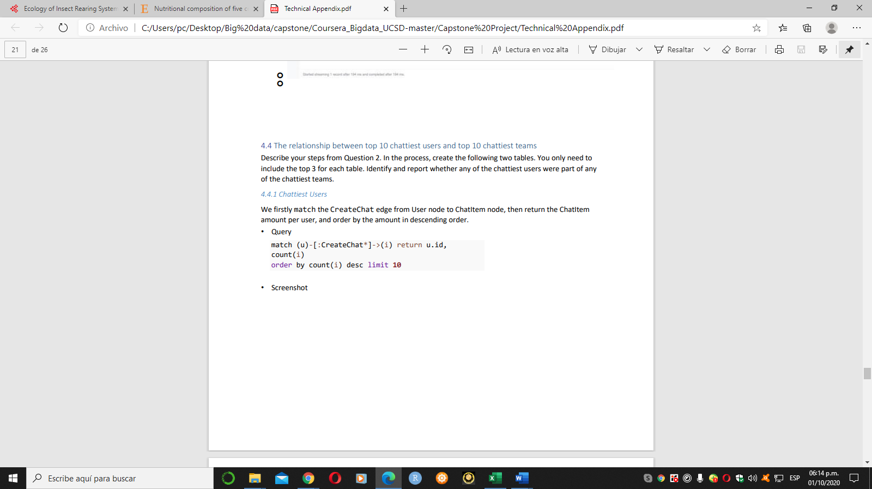
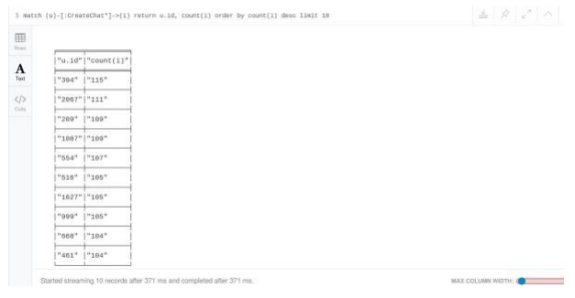

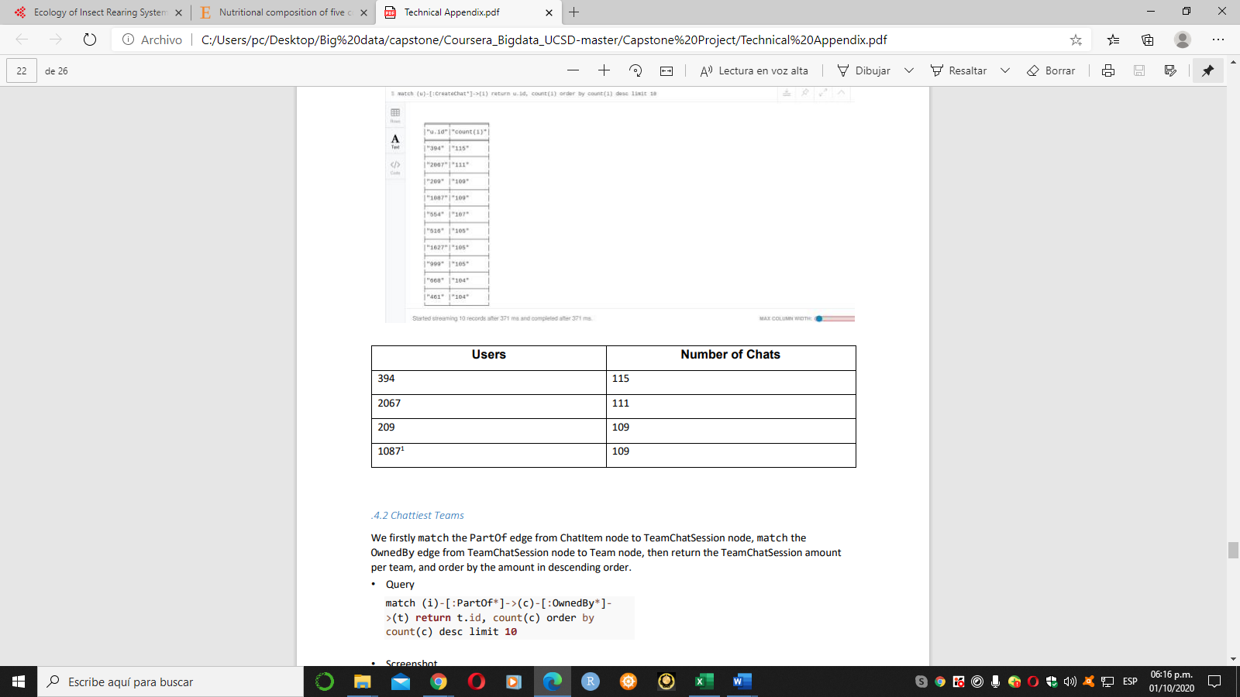
Chattiest Teams
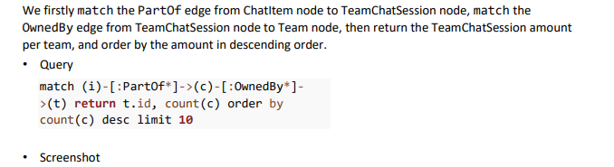
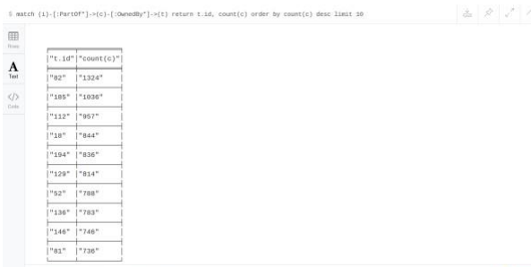

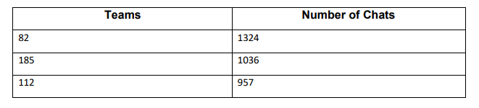

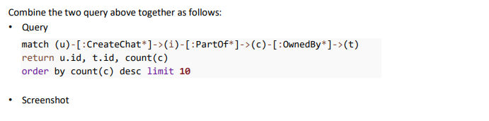
Final Result
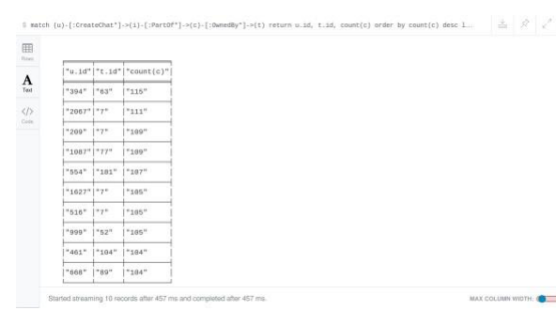

As result shows, the user 999, which in the team 52 is part of the top 10 chattiest teams, but other 9 users are not part of the top 10 chattiest teams. This states that most of the chattiest users are not in the chattiest teams.

How Active Are Groups of Users?

In this question, we will compute an estimate of how “dense” the neighborhood of a node is. In the context of chat that translates to how mutually interactive a certain group of users are. If we can identify these highly interactive neighborhoods, we can potentially target some members of the neighborhood for direct advertising. We will do this in a series of steps.

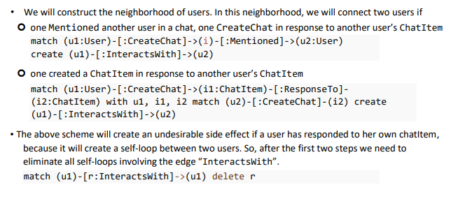
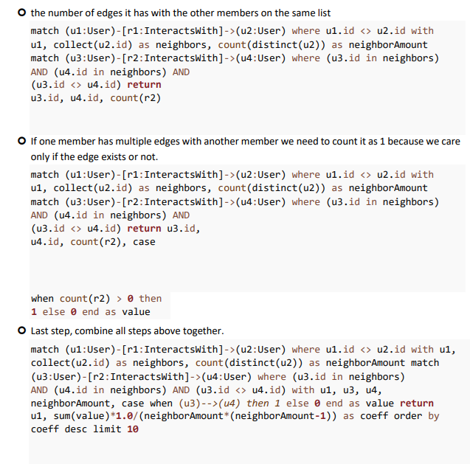
For each of these neighbors, we need to find
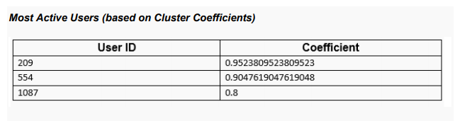

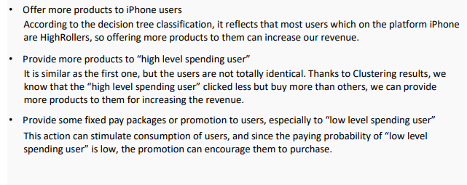
Recommended Actions

